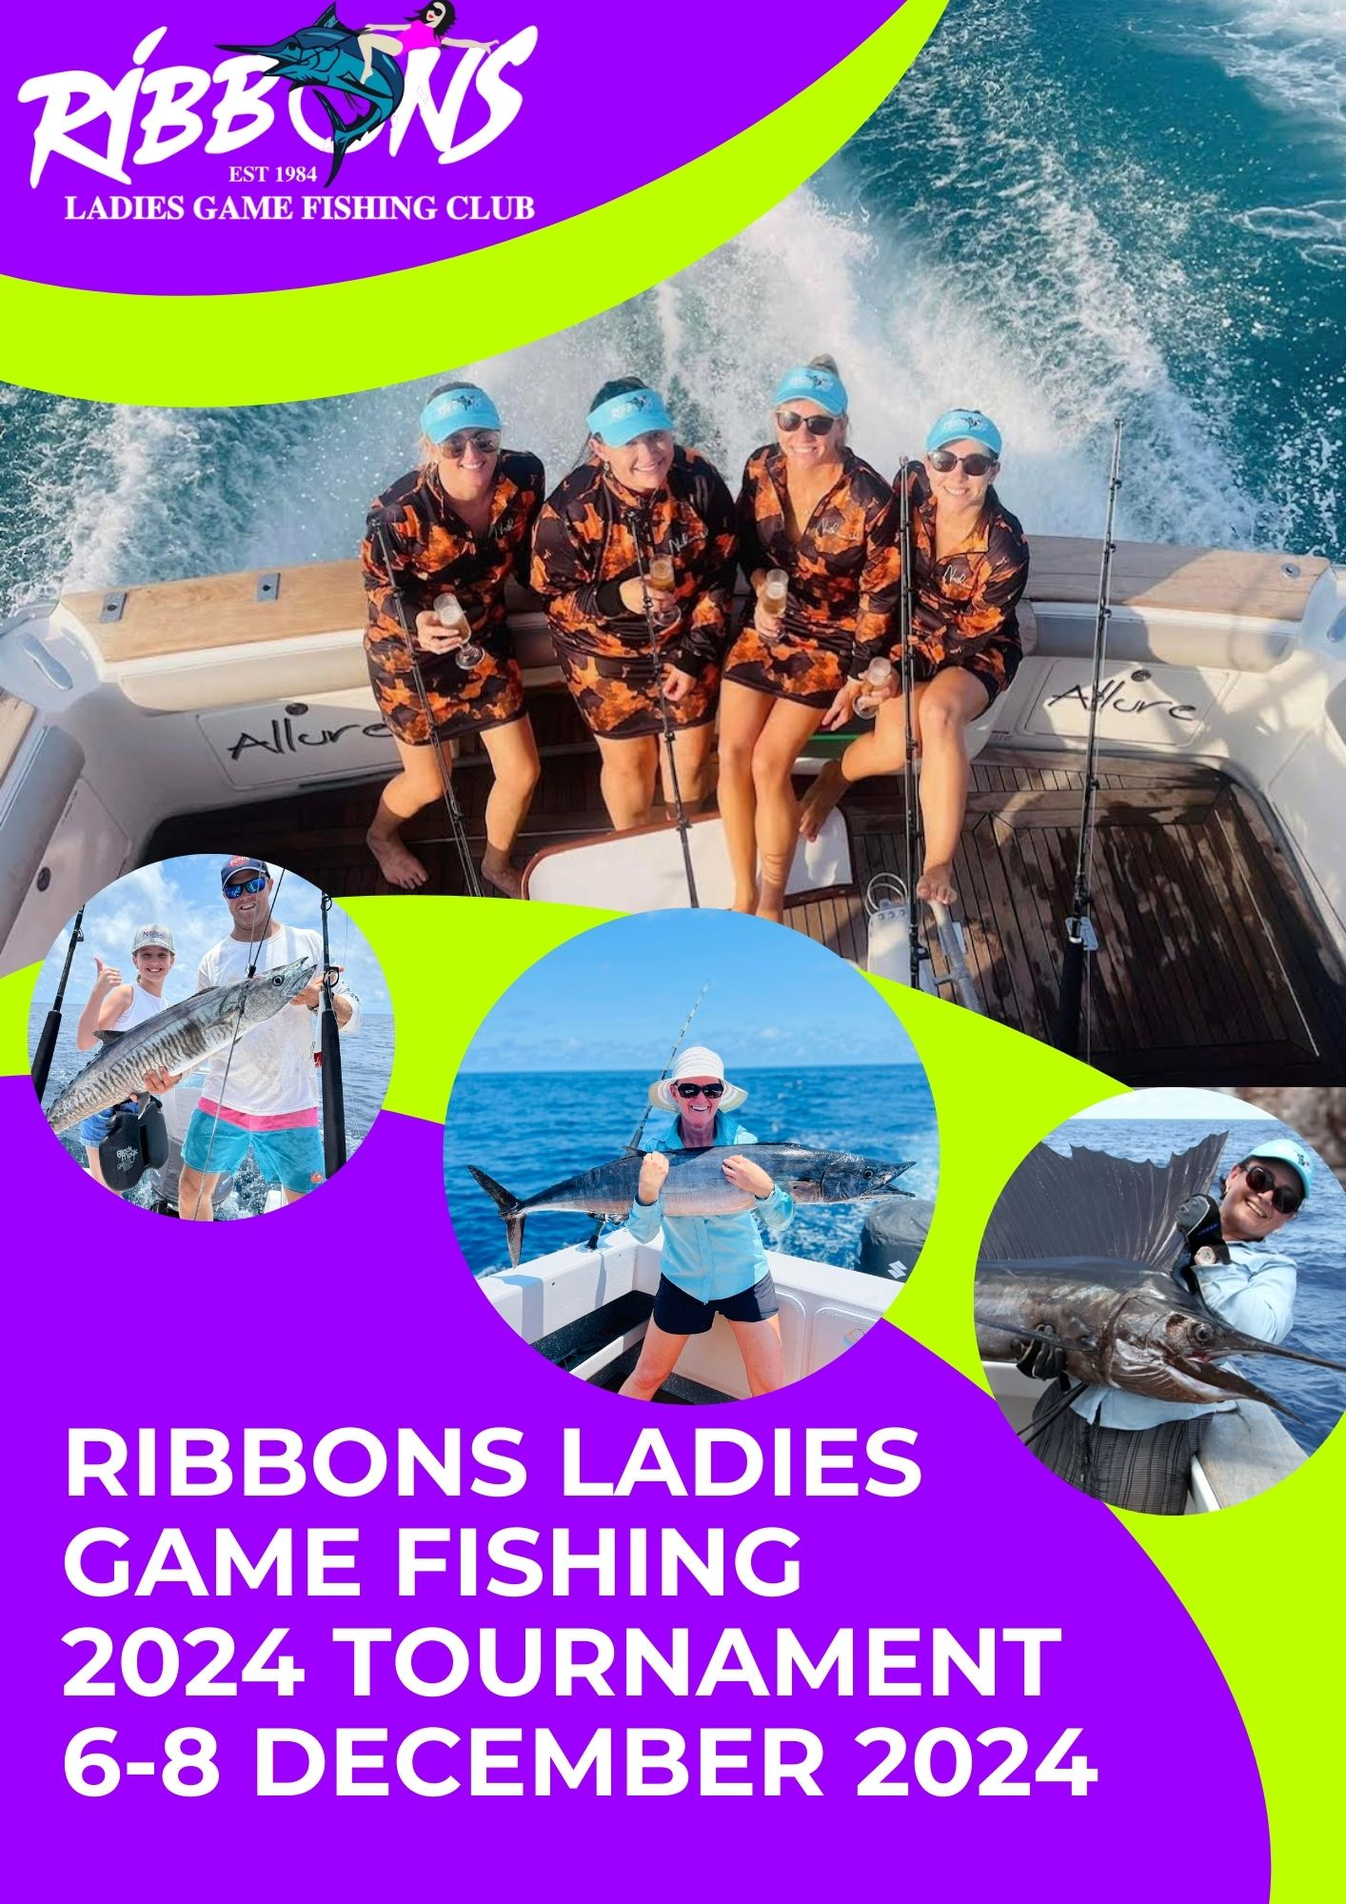

***2024 SKIPPER’S INFORMATION AND CODE OF CONDUCT***

This booklet which will be in the tournament bag, has been put together so you have information on:

* Ribbons Rules
* Covid Information
* Safety Contacts
* Information on claiming a record
* Sailpast Information

The radio boat for the 2024 tournament is “New Moon” by calling “Ribbons Base”. Scheds will take place at 1105, 1405 and 1630 on VHF 81. All boats must have a working VHF Radio.

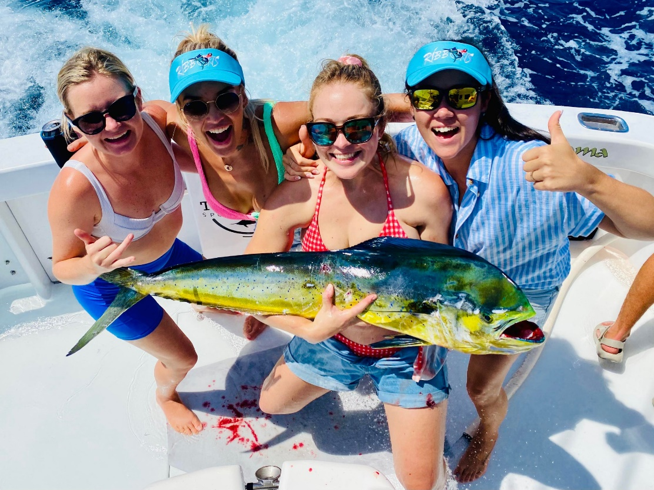

**2024 Tournament RULES**

**QUALIFICATIONS FOR ANGLER ENTRY:** As this is a Ladies ONLY tournament, all competitors must be female. All competitors including foreign anglers/residents MUST be a current financial member of the QGFA or GFAA affiliate club. Anglers may be asked to provide proof of current membership. The Ribbons reserves the right to refuse entry to any angler.

Anglers fees provide entry to the tournament and include the RED levy which the club pays to the QGFA

**BOAT SKIPPERS AND DECKIES REQUIREMENTS:**

In accordance with QGFA requirements all Boat Skippers and assisting crew who are aiding in the event of catching a fish are required to be financial members of a QGFA or GFAA affiliated club. Skipper and Deckie may be asked to provide proof of current membership. The Ribbons reserves the right to refuse Skipper or Deckie entry into the tournament.

**TOURNAMENT CONDUCT:**

Ribbons reserves the right at any stage of the competition to eject, disqualify or deduct points from individuals or teams who are deemed to have conducted themselves in a disrespectful manner and are deemed to have brought the sport of Game fishing or the tournament into disrepute. In the event that an angler, or a team of anglers/crew/skipper are ejected no result or refund of fees will be entered into.

**BOAT INSURANCE**

All boats nominating to fish the tournament are required to have current boat insurance. Details of such insurance must be completed on the entry form supplied along with a photocopy of your insurance certificate. Should a boat not have insurance, nor be able to supply evidence of insurance and certificate prior to the commencement of the tournament, that boat shall be excluded from participating in the tournament. All onboard safety remains the responsibility of the owner / skipper .

**BOAT LENGTH**

For clarification “Boat Length” will be considered as the measured length of the boat in accordance with these QGFA guides and NOT the manufactures advertised boat length.

Specified boat lengths will be measured from the transom where the motor or outdrive of the boat is bolted to the boat. Where the boat has a pod fitted, the transom of the pod where the motors are bolted will be counted in the boat length, to the forward most point of the boat, but will exclude any bowsprit or forward projecting anchor location as per the QGFA Guideline for determining boat length.

**CHANGES TO REGISTRATION:**

Changes to team registration i.e. team name, etc will NOT be accepted within 72 hours of the briefing.

**LINE CLASS: 10 kg, 15kg or 24kg** - If line class is not recorded on score sheet, points will be allocated according to 24kg line class

**TAG & RELEASE:**

All billfish to be tagged and released for points, using GFAA approved billfish tag (NSW Department of Primary Industries). Tags are available at the briefing.

**ELIGIBLE SPECIES:**

All species except sharks and barracuda that are listed in GFAA Record Charts.

**EDIBLE GAME FISH:**

As defined by the committee are: Cobia, Mackerel, Mahi Mahi, Dogtooth Tuna, Yellowfin Tuna and Wahoo. Except for record claims, edible fish **MUST** be gilled and gutted on capture and kept on ice and presented in edible condition. Failure to gill AND gut edible species will result in the fish being allocated the minimal point allocation applicable.

An additional 10% is to be added to the weight of the gilled AND gutted fish before calculation of points. Edible fish under line class can be weighed.

**OTHER GAME FISH** (i.e. those not considered edible by the committee) must be line class to be weighed and receive points.

**POINTS SCORE IS AS FOLLOWS:**

All fish weighed must be legal fish in size and bag limits. In the event of a tie, the first team or angler reaching the winning total will be declared the winner.

|  |  |
| --- | --- |
| Billfish: | 10kg line = 600+50% Bonus = 900 Points |
|  | 15kg line = 500+50% Bonus = 750 Points |
|  | 24kg line = 400+50% Bonus = 600 Points |
| Gamefish: | Weight of fish x 100 divided by line class |

**FISHING GROUNDS:** Opal Reef to Raaf Shoals. Be aware of Green Zone Rules and Regulations.

**SAILPAST:** All vessels must participate in the sail past, commencing from the Marlin Wharf at **0700 hours**. Vessels must pass the Marlin Jetty in single file, as per instructions given at the briefing for the judging of Best Decorated Boat. The committee will individually consider exceptions to this rule.

Departure before 0700 hrs will not be permitted under any circumstance.

**FISHING HOURS:** Fishing will commence at **0830 hours** and cease at **1700 hours**. Any fish hooked before cease fishing may be played out and is eligible for points, provided the hook up is notified at cease of fishing and the team meets the weigh in cut off time of 2000 hours.

**WEIGH IN:** All captured fish must be weighed at the Marlin Marina between 1800 hours and 2000 hours. All teams must present completed Score Sheets and Tag Cards to the Weighmaster, even if no fish were caught. Potential records must be announced at time of capture and must not be mutilated. **Reminder-** As per the recently revised Fisheries QLD regulations, only 2 Spanish Mackerel per boat are permitted to be weighed.

**TEAMS:** Teams must be a minimum of 2 and a maximum of 4 anglers.

**PROTESTS and DISPUTES:**

A Dispute Committee comprising members from a minimum of three clubs (where possible the tournament club and two other clubs should form any protest committee and if possible, the clubs forming the protest committee should not include a club that the protested or protestor are members of) will hear any protests provided they are submitted in writing in accordance with tournament rules for disputes. The committee’s decision will be final, and no further discussion will be entered into.All protests must be submitted in writing by the team captain to the executive committee no later than 0900 hours Sunday 8thof December 2024.

**RADIOS:** All competing vessels must carry a VHF radio in good working order. All competing vessels must remain contactable at all times via radio or agreed alternative communication, by either Game Base or another vessel. Failure to maintain contact may result in team disqualification. A boat logging off from Ribbons Base for the day (even before cease fishing) will be deemed as no longer fishing within the tournament for that day and thereby no longer be eligible to score points for fish caught after doing so. (This does in no way mean a boat may not log on with Marine Rescue Services for safety purposes).

**RADIO SCHEDS:** Frequency: VHF 81 Times: 1105, 1405, 1630 HRS

**COVID 19 SAFETY REQUIREMENTS**

At this event health and safety are our priority so please adhere to the following:

Covid 19 Event Safety

* Stay home if you are sick
* Stay 1.5m away from other people
* Wash your hands with soap and water, or hand sanitiser
* Leave a location if it is crowded
* If you have any Covid 19 symptoms, no matter how mild, get tested.

If you have any concerns about your health, contact your doctor or Qld Health on 13HEALTH

The Ribbons committee have the right to refuse service or participation in our event and must insist that anyone unwell or with Covid like symptoms leave the event.

Thank you for your understanding and adherence to these requirements

**GENERAL SAFETY AND CONTACTS**

Ribbons aim to run a safe and enjoyable tournament . We run this event under an Aquatic Event permit from MSQ. We have a Safety Management Plan which may be viewed at the briefing or contact the committee for a copy.

In the event of an emergency please contact the Cairns Coast Guard on Ch 16 or 81 or phone 4051 2192

Cairns VTS Ch 12 or Ribbons Base on VHF 16 or 81

Other contacts :000 Cairns Police 4030 7000

Marlin Marina 4052 3866

Ribbons contact who will be on shore and may be able to assist with any unexpected occurrences is

Contact person to be appointed

**NEVER THROW DEAD FISH INTO THE MARINA OR TRINITY INLET**

**BRIEFING INFORMATION**

**PLEASE ATTEND THE BRIEFING ON FRIDAY 6th DECEMBER FOR FULL BRIEFING**

**RULE CLARIFICATION:**

It is the responsibility of all anglers and skippers to ensure that you are all fishing according to our tournament rules. You can find our tournament rules in the brochure. You must also be aware of the QGFA/GFAA rules which we fish under. You can find these rules in your annual GFAA fishing journals or at [www.gfaa.asn.au](http://www.gfaa.asn.au/).

Please note, failure to fish within the Ribbons and GFAA rules may lead to fish being disqualified from being eligible to score points for Anglers and Teams.

Please be aware of individual bag limits and boat bag limits for Queensland Waters. Skippers, please note that you may be asked to provide a sample of line over the course of the tournament.

**SCORESHEETS:**

Scoresheets have been colour coded to the fish ribbons and are included in the middle of this booklet and are perforated for easy removal. Please fill out completely and correctly. Please submit to the weigh master and scorer on Saturday afternoon, even if you didn’t catch any fish. Submit any Greenie and Encouragements Award nominations with your scoresheets – please don’t forget to write your boat name and the angler's name and circle junior or senior angler!

**PHOTOS AND VIDEO:**

If you are using a traditional camera, please hand in your SD Card with your scoresheet and they will be returned at the Presentation Dinner. If your photos and video’s are located on mobile devices without SD cards, the Ribbons committee will provide information regarding photo and video sharing platforms to upload your content so that it can be used at the presentation gala evening.

**NOTICE OF PHOTOGRAPHY AND FILMING:**

Please note that filming/ photography is taking place during the tournament for promotional and archival purposes. The photographs and recordings made are likely to appear on our website or social media platforms. If you would prefer not to be photographed please let the Ribbons committee know or the photographer know.

Any photographs or video submitted to the Ribbons via Sd cards, airdrop, website, email or on Ribbons social media sites may be used by Ribbons for promotional and archival purposes associated with the running of our tournaments and functions

**PRESENTATION NIGHT:**

Our presentation dinner will be held this year at the Cairns Pullman in Abbott St. We will be kicking off pre-dinner drinks at 5.30 pm and we will be looking to power through the evening’s proceedings so that we can all kick back and enjoy the entertainment at the end of the evening.

………..

**CLAIMING A RECORD**

**If you think you have caught a record and want to submit a record, please notify Ribbons base.**

The responsibility for lodging records falls to the angler. Ribbons will assist any record application by having the weighmaster complete any required paperwork and submit a copy of the certification of calibration for the scales. We can also assist with liaising with QGFA and GFAA.

For more information, please visit [http://www.gfaa.asn.au](http://www.gfaa.asn.au/).

**SAILPAST INFORMATION**

**SAILPAST:**

Sunrise: 5.35am Sunset: 6.41pm

Tides: High 1.13am - 1.59m, Low 6.46 am - 1.17m

High 2.39 pm - 2.56m, Low 10.11pm - 1.26m

The following risks have been identified with regards to this tournament and the sailpast in particular.

* Increased risk of collision due to number of vessels in close proximity.
* Increased risk of collision of a vessel with wharf and navigation pylons during the sailpast.
* Increased radio VHF use due to number of vessels leading to suppression of emergency calls from other vessels.

The following procedures are to be followed to reduce these risks to an acceptable level.

Please leave the Marlin Marina by 6.45am. A radio call will be made to begin departing the marina. Please be aware of other traffic entering and exiting the marina as well as general inlet traffic throughout the sailpast. Ensure that it is safe to power up down the leads and take care overtaking other boats.

When you leave the Marlin Marina proceed south in the inlet and assemble in front of the Hilton hotel.

In your tournament bag you will have a list of boats, please read this sheet and identify the boat you will be following.

Please locate the boats that you are to follow in the sailpast and be aware some boats may be absent as they are leaving from Yorkeys Knob. These boats will be indicated on Briefing night.

Radio boat “New Moon” will alert all boats when the sailpast commences on Frequency VH81, **so make sure your radios are on and you are listening!!** Please avoid excessive or inappropriate use of the radio on VH 81 and 16 as these frequencies can be used for safety communication by vessels unrelated to the event.

2023 winning Team will be on “Wild Turkey” leading the sailpast, followed by boats in numerical order as indicated on the sheet, **in single file SLOWLY.**

**Do not be close to the boat in front of you.**

Boat Numbers are to be displayed on BOTH sides of your boat and be visible to the judges on the Northern End of the Marlin Marina.

If any visiting moored vessels make access to the Northern end of the marina impossible, then the sailpast will be judged from the shoreline in-front of the Hilton Hotel. You will be notified at the briefing where the judges will be.

Please come as close as safety permits.

Once clear of the northern point of the Marlin Marina the sailpast requirements are no longer necessary and you may proceed to your desired fishing locations as per the fishing grounds. Secure your decorations.

Radio boat “New Moon.” can be contacted as “Ribbons Base” and will conduct the scheds.

**Have An Enjoyable & Safe Tournament. Good Luck**

